<http://www.nydailynews.com/life-style/health/sloan-kettering-study-acupuncture-works-chronic-pain-article-1.1156095>

[Daily News](http://www.nydailynews.com/)

[**Health**](http://www.nydailynews.com/life-style/health)

# Sloan-Kettering study: Acupuncture works for chronic pain

## NYC researcher says any needles better than none for aches

[Comments (1)](http://www.nydailynews.com/life-style/health/sloan-kettering-study-acupuncture-works-chronic-pain-article-1.1156095?print#commentpostform) By [Heidi Evans](http://www.nydailynews.com/authors?author=Heidi%20Evans) / NEW YORK DAILY NEWS

##### Monday, September 10, 2012, 3:59 PM

* [Print](http://www.nydailynews.com/life-style/health/sloan-kettering-study-acupuncture-works-chronic-pain-article-1.1156095?print)

* [Comment](http://www.nydailynews.com/life-style/health/sloan-kettering-study-acupuncture-works-chronic-pain-article-1.1156095?print" \l "commentpostform)

A new study by Sloan-Kettering researchers says acupuncture is an effective treatment for chronic pain.

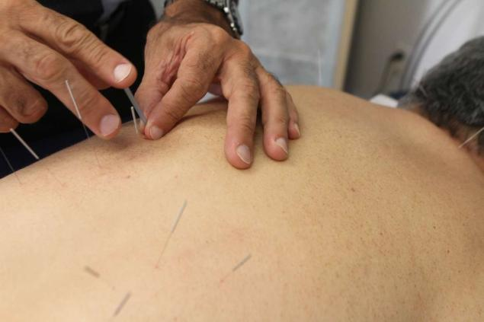

Powered by InformMariela Lombard/for New York Daily News

Acupuncturist Russell Kordas works on patient, Peter Lawrence during an acupuncture treatment in Manhattan.

Skeptics dismiss it as hocus-pocus, and insurance companies often won’t pay for it.

But new research from one of the city’s top hospitals has determined that the ancient practice of acupuncture is an effective treatment for chronic pain.

Investigators at Memorial Sloan-Kettering Cancer Center undertook a huge statistical analysis of more than two dozen studies involving 17,922 patients with back, neck and shoulder pain, osteoarthritis or chronic headaches.

“Many clinicians consider acupuncture to be merely a potent placebo and feel uncomfortable referring their patients to an acupuncturist,” statistician Andrew Vickers said.

“But our findings suggest that the effects of acupuncture go over and above the placebo effect.”

The study, published in the Archives of Internal Medicine, found that patients who received acupuncture reported relief more often than those who got none or who got “sham” acupuncture in which the needles were not perfectly placed.

Sloan-Kettering did the study because cancer patients suffer from pain that doesn’t always respond to drugs and it wanted to see if acupuncture actually works.

“Acupuncture has been extremely controversial for 40 years in the U.S,” Vickers said.

“We have now done the most rigorous analysis to date, as statisticians, to find out whether it works. We have found very robust evidence that acupuncture is a reasonable referral option for chronic pain.”

The study found that proper acupuncture brought more relief than needles that were put in the wrong spot.

But even poorly placed needles were better than no acupuncture at all — possibly due to the relief of pain-suppressing endorphins.

Under traditional Chinese medicine theory, acupuncture heals by regulating the flow of “qi” or “vital energy” through the body.

Needles as thin as a cat’s whisker can be placed in any of 360 points on the body.

A growing number of physicians recommend it and some 3 million Americans go under the needle every year.

Dr. Ronnie Hertz, director of pain management at St. Lukes-Roosevelt Hospital, said he recommends acupuncture to 20% of his chronic-pain patients.

“I think it very effective, especially for neck pain,” said Hertz. “The big problem with acupuncture is that insurance companies don’t pay for it which is unfortunate. A lot of people with chronic pain can benefit, but not everyone can afford the $50 to $100 a session.”

Manhattan acupuncturist Russell Kordas, who’s been practicing for over 12 years, said acceptance has grown.

“When I was first working in a Bronx clinic, I would mention acupunture and people would run away. Now, a lot of people want to give it a try and medical doctors are much more open to referring patients,” said Kordas.

“We tend to fill in nicely for chronic conditions that aren’t too serious but need relief.”

The Sloan findings came as no surprise to Peter Lawrence, a sales executive from the upper East Side.

“Whenever I get any type of sports injury, the first thing I think of is acupuncture,” said Lawrence, 64, who has done it for a pinched nerve in his upper back and neck and for sciatica.

“For me it works very well.”

Read more: <http://www.nydailynews.com/life-style/health/sloan-kettering-study-acupuncture-works-chronic-pain-article-1.1156095#ixzz2rFh0VXkK>